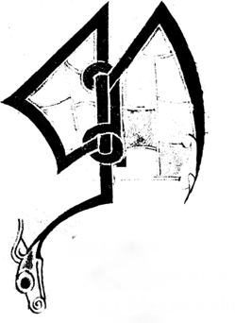
29th Irish Conference of Medievalists
July 1-3 2015
Paper Submission Form

The Paper Submission Form should be submitted with an abstract of the proposed paper. The abstract should be no more than 150 words long.

Paper Title: ––––––––––––––––––––––––––––––––––––––––––––––––––––
Name: ––––––––––––––––––––––––––––––––––––––––––––––––––––––––
Affiliation: –––––––––––––––––––––––––––––––––––––––––––––––––––––

Email the completed application to ICM2015@ucd.ie

